Web data extraction Requirement document

Suggested Code Policy:

1. Copy the Project folder structure from bellow github link.

<https://github.com/pool23/pool_UK>

1. Use Python(Mandatory) with BeautifulSoup, Scrapy and Selenium (Feel free to use any other Python libraries)
2. Store Scrapped data with provided file name and CSV format.

Work 1:

**Scarped Data Format (File Name - Natwest_Data_Deposit_<YYYY_MM_DD>.csv)**

|  |  |
| --- | --- |
| **Column NAMES for Deposits** | **Default Values** |
| Date | Date(YYYY-MM-DD) |
| Bank_Native_Country | UK |
| State | London |
| Bank_Name | NatWest |
| Bank_Local_Currency | GBP |
| Bank_Type | Bank |
| Bank_Product | Deposits |
| Bank_Product_Type | SCRAPED DATA - Format should be Savings/Current/Term Deposits |
| Bank_Product_Name | SCRAPED DATA |
| Balance | SCRAPED DATA |
| Bank_Offer_Feature | Offline by default and Online where product name has keyword Online |
| Term in Months | SCRAPED DATA |
| Interest_Type | SCRAPED DATA - Default is Variable |
| Interest | SCRAPED DATA |
| AER | SCRAPED DATA |
| Bank_Product_Code | LEAVE THIS COLUMN BLANK |

**Savings Account**

<https://personal.natwest.com/personal/savings/compare-savings-accounts-new.html#ISAdesktop>

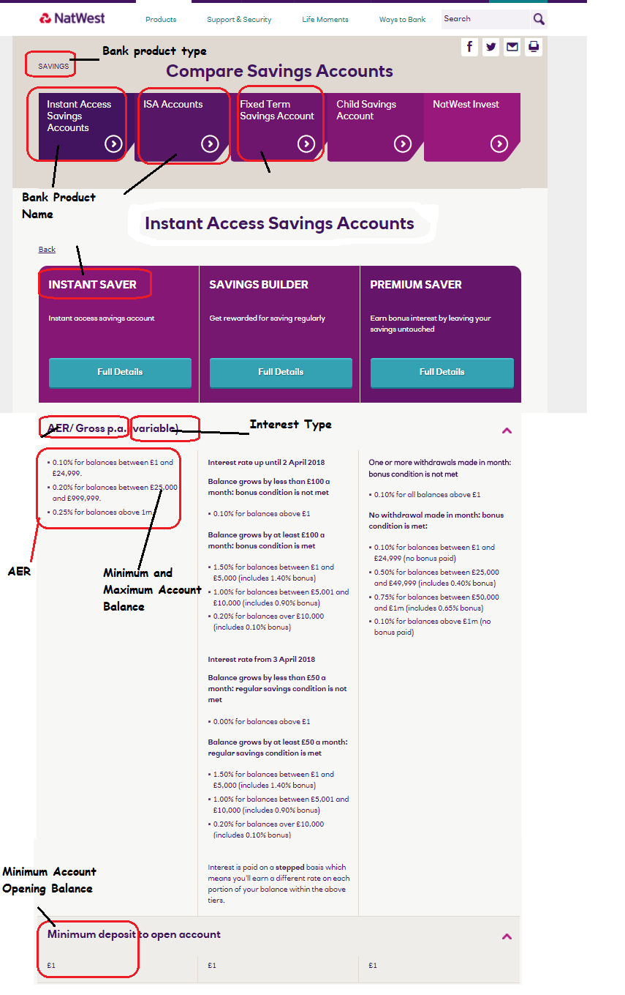

[**https://personal.natwest.com/personal/savings/compare-savings-accounts-new.html#ISAdesktop**](https://personal.natwest.com/personal/savings/compare-savings-accounts-new.html#ISAdesktop)

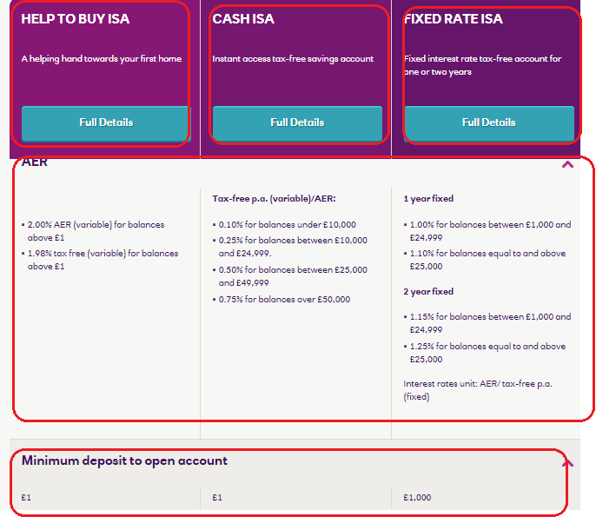

[**https://personal.natwest.com/personal/savings/compare-savings-accounts-new.html#FTSAmobile**](https://personal.natwest.com/personal/savings/compare-savings-accounts-new.html#FTSAmobile)

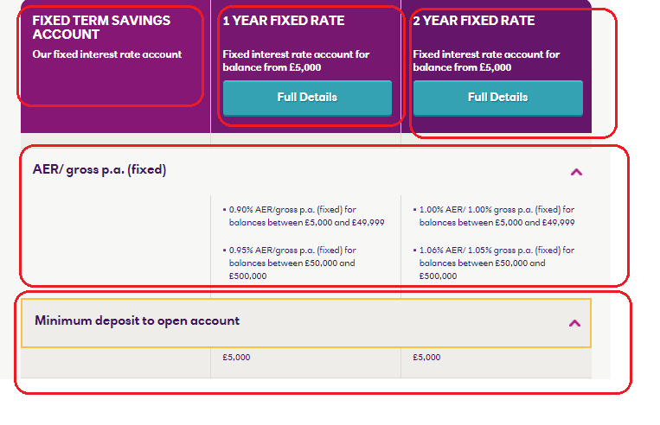

Work 2: Mortgage Rates

|  |  |
| --- | --- |
| **Mortgages Columns** | **Default Values** |
| Date | Date(YYYY-MM-DD) |
| Bank_Native_Country | UK |
| State | London |
| Bank_Name | NatWest |
| Bank_Local_Currency | GBP |
| Bank_Type | Bank |
| Bank_Product | Mortgages |
| Bank_Product_Type | Mortgages |
| Bank_Product_Name | SCRAPED DATA |
| Min_Loan_Amount | SCRAPED DATA |
| Bank_Offer_Feature | Offline |
| Term (Y) | SCRAPED DATA |
| Interest_Type | SCRAPED DATA (Variable, by default) |
| Interest | SCRAPED DATA |
| APRC | SCRAPED DATA |
| Mortgage_Loan_Amt | SCRAPED DATA |
| Mortgage_Down_Payment | 20% |
| Mortgage_Category | New Purchase |
| Mortgage_Reason | Primary Residence |
| Mortgage_Pymt_Mode | Principle + Interest |
| Fixed_Rate_Term | SCRAPED DATA <from title> |
| Bank_Product_Code | LEAVE THIS COLUMN BLANK |

<https://personal.natwest.com/personal/mortgages/mortgage-calculators/mortgage-rate-finder-mortgage-calculator-HMCIB-GaAIP.html?SC_MRF=NC_RFTB&adobe_mc_ref=https%25253A%25252F%25252Fpersonal.natwest.com%25252Fpersonal%25252Fmortgages%25252Ffirst-time-buyers.html&adobe_mc_sdid=SDID%25253D58C8026FAA090FBA-28CBD945A3F2B97C%25257CMCORGID%25253DC50417FE52CB33480A490D4C%25252540AdobeOrg%25257CTS%25253D1521116898>

***The mortgages site is very similar to RBS, so please try to reuse the codes used for the RBS here.***

Case 1: Property Value: 90,000; Your deposit: 18,000

Case 2: Property Value: 270,000; Your deposit: 54,000

Case 3: Property Value: 450,000; Your deposit: 90,000

***From NatWest***

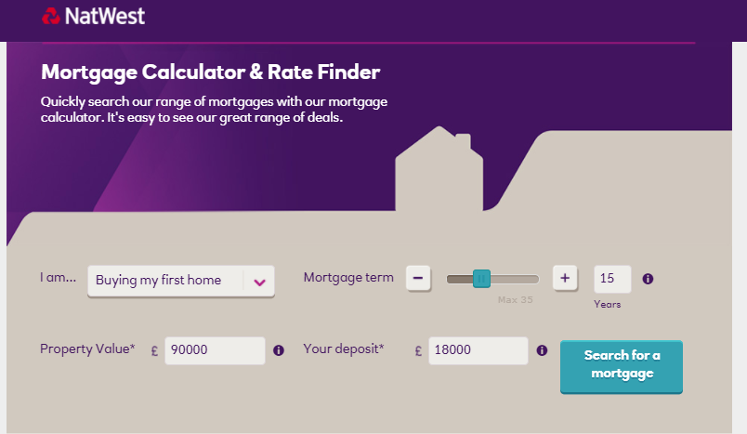

***From RBS***

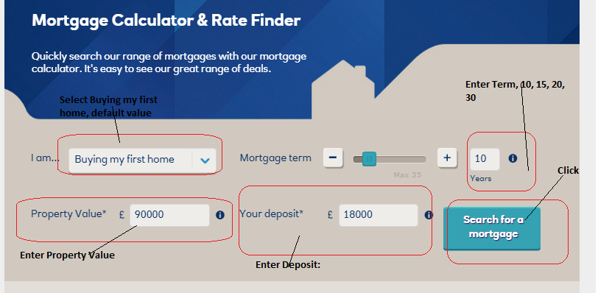

Click on Search for a mortgage

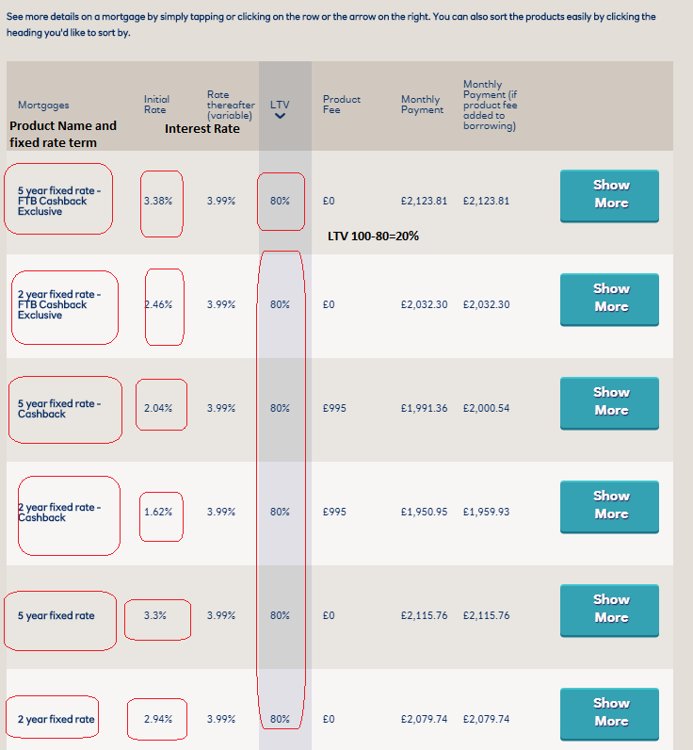

Click on show more

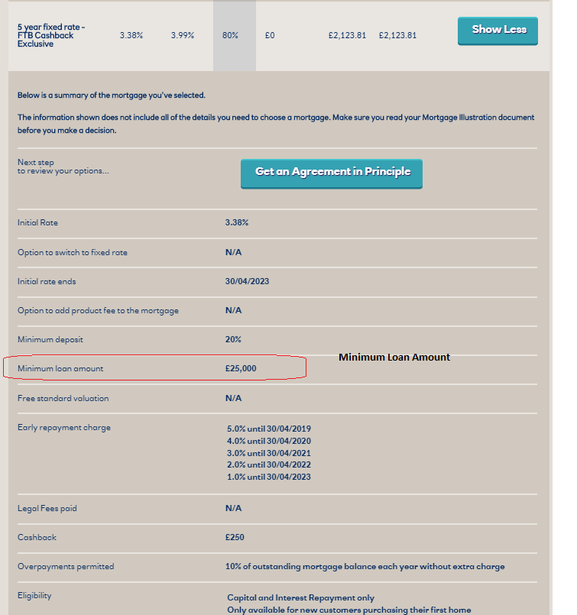

Repeat for 10, 15, 25, 30 year loan term

**Example for 1st Product:**

Product Name: 2 Year Fixed LTV 80%

Term: 10

Fixed_Rate_Term: 5

Mortgage_Down_Pymt: 20%

Interest: 3.38%

Min_Loan_Amt: 25000